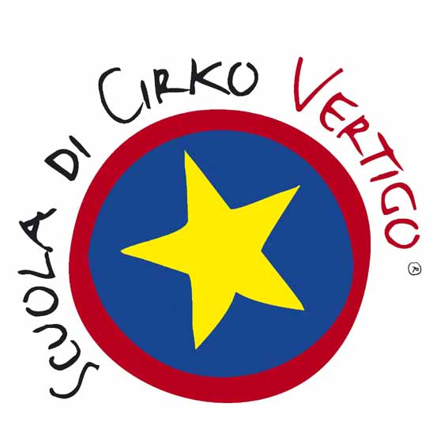
VOCATIONAL TRAINING COURSE FOR
CONTEMPORARY CIRCUS ARTIST

APPLICATION FORM 2015 / 2017

Name |_________________________________________________________|

Surname |_________________________________________________________|

Date of birth |__|__|/ |__|__|/ |__|__|__|__| Place of Birth |_______________________________

Residence
Address |_____________________________________________________________________| |__|__|__|__|__|

Suburb/City |_______________________________________________________________________________|

Tel. Number |__|__|__|__|/|__|__|__|__|__|__|__|__| Mobile number |__|__|__|/|__|__|__|__|__|__|__|__|

e-mail |___________________________________________________________________________|

High School leaving certificate ___________________________________________________________ (to be attached to the application form)

Please specify your experience in circus techniques:

Please specify in which circus technique you would like to specialize during the two years:

Please specify any musical instrument played:

Motivation letter

_______________________________________________________________________________________________

_______________________________________________________________________________________________

_______________________________________________________________________________________________

_______________________________________________________________________________________________

_______________________________________________________________________________________________

_______________________________________________________________________________________________

_______________________________________________________________________________________________

I WOULD LIKE TO AUDITION ON THE : 23 and 24 June □ 9 and 10 September □

